PBW5003

UML Diagram

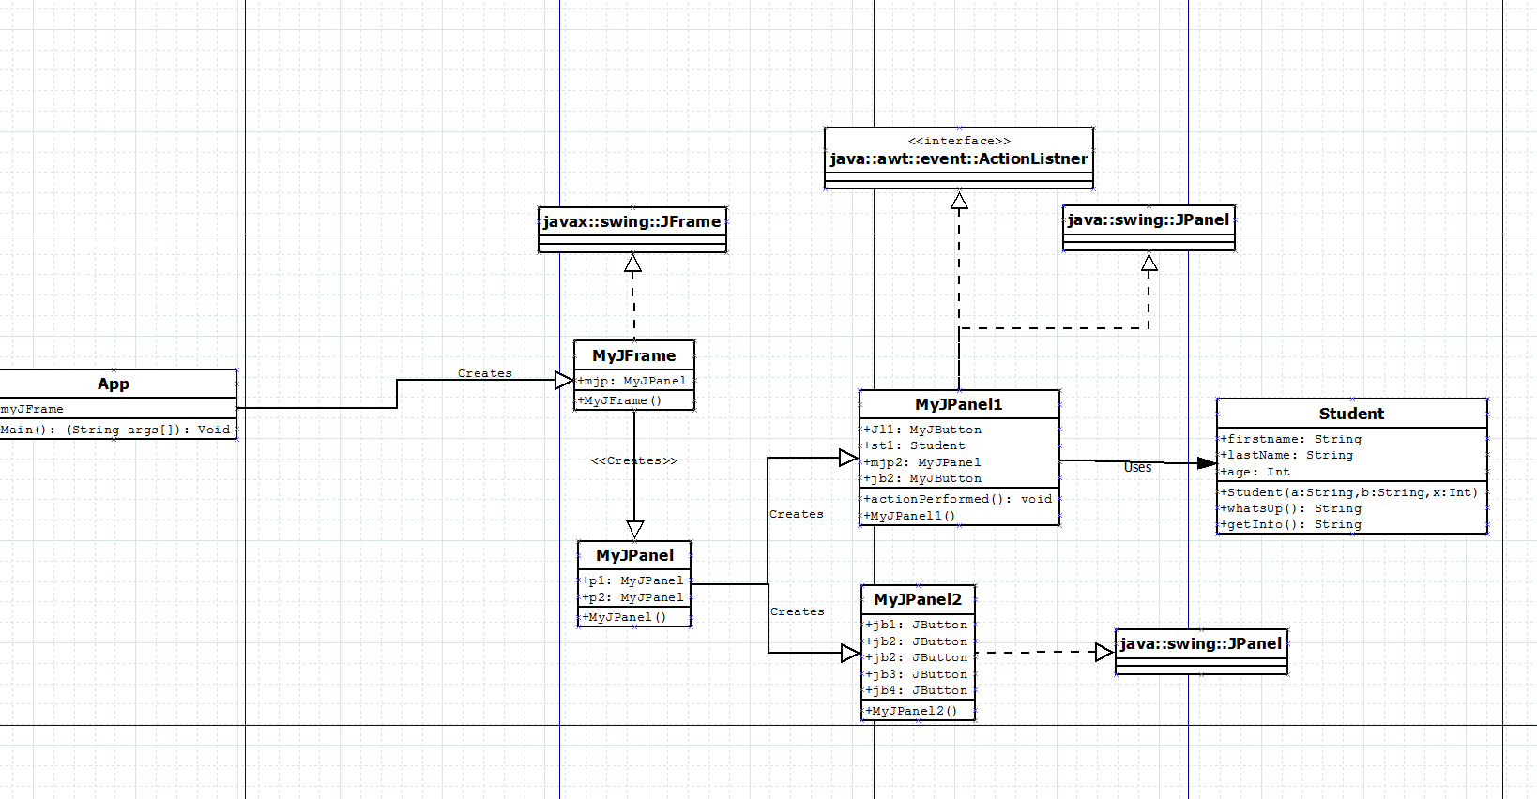

PBW5003 USE CASE DIAGRAM

